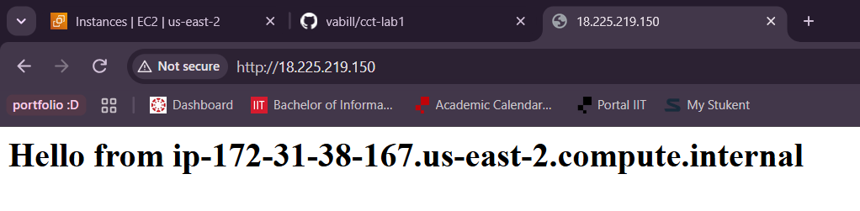
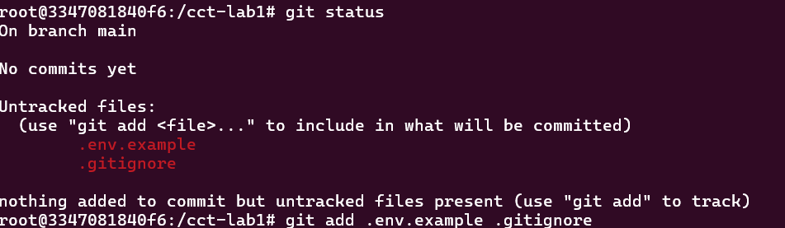
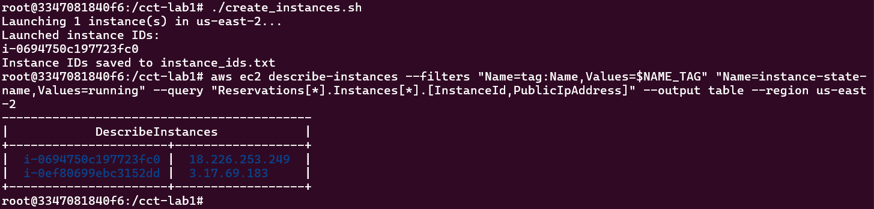
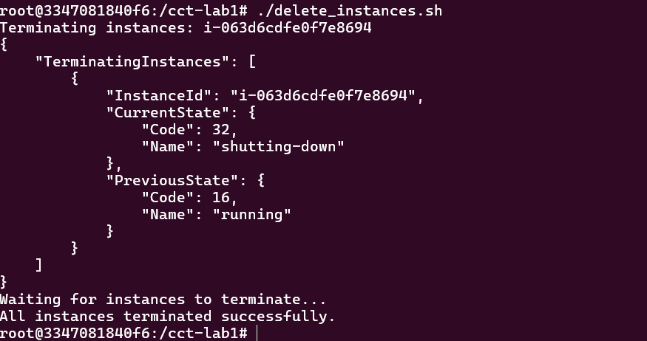
.env files are excluded from Git because they contain sensitive information like passwords, API keys, database credentials, and AWS/GitHub tokens. Even if a repository is private, it is still possible for someone to gain access to the repo, accidentally share it, or expose its history. Keeping .env files out of Git helps protect these secrets and prevents them from accidentally committed and distributed. That’s why we used a .env.example file that had placeholders values of anything secret, to show what information is needed.

